DOCUMENTATION FOR INSIGHTS

INTRODUCTION

We were provided with 6 datasets i.e. Plans table, New Policies table, Patients table, Patients History table, Hospitals table and New Admissions table.

With the above datasets we were able to derive some useful insights that would help WeCure to increase their efficiency.

The insights are as follows:

1. Count of Hospitals by Sector:

Output-

Private sector has more hospitals.

1. Average Number of Licensed Beds by State:

Output-

1. Percentage of Smokers among Patients:

Output-

5.2% of total patients are smokers.

1. Top 5 Hospitals with the Most Admissions:

Output-

1. Percentage of Patients with Diabetes and Hypertension:

Output-

Almost 20% of patients have diabetes and hypertension

1. Average Daily Premium by Insurance Plan:

Output-

1. Percentage of Patients with Heart Failure:

Output-

28.2% patients have heart failure.

1. Total Insurance Coverage by Plan:

Output-

1. Determine whether patients with different insurance plans have varying outcomes (e.g., readmission rates or mortality rates):

Output-

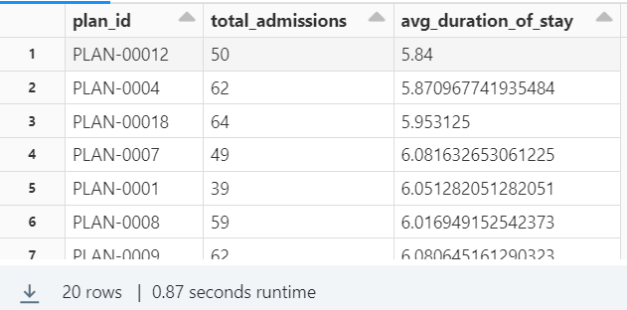

1. Assess the efficiency of resource allocation by analyzing the usage of ICU beds and ventilators in hospitals:

Output-

1. Analyze the demographics of patients admitted to hospitals, segmented by the sector (public or government) of the hospital they were admitted to:

Output-

1. Analyze the popularity of different insurance plans among patients using data from the plans and policies new data frames:

Output-

1. Identify patients who have a long-term relationship with specific hospitals or providers using data from the hospitals, new admissions, and patient data frames:

Output-

1. Number of patients per hospital:

Output-

1. Highest number of emergency patients on a particular day:

Output-

1. Geographical distribution of patients:

Output-

1. Year wise and month wise no of emergency cases that lead to death:

Output-

1. Average duration of stay in hospitals in case of emergency to get discharged:

Output-

1. State wise location wise total licensed beds:

Output-

Pune has the most number of licensed beds.

1. State wise location wise count of government hospitals:

Output-

Delhi has the most government hospitals.

1. State wise location wise count of hospitals:

Output-

Bangalore has the most number of hospitals.